Online Trick Training Program
Draft Emails to send your clients

Feel free to use these two emails to create marketing material to promote the online trick training program to your client. You can use all of it, or part of it, or none of it.

We would recommend editing it enough so that it sounds like your brand’s voice and feel free to add any additional bonus items that you might include with the course (if applicable)

Be sure to include a link where your clients can sign up too!

EMAIL 1:

OPENING PARAGRAPH – TWO OPTIONS

OPTION 1 (Recommended)
This is a crazy time we are in, isn’t it? The world seemed to literally change overnight for all of us. We know so many of you had to cancel your travel plans and are disappointed that you can’t go on vacations and we miss your pets too! Many of our clients have been checking in on us and we appreciate the concern. We have made many changes and, like you, we are waiting to see how this all plays out. We hope to get back to our normal routine soon. BUT…in the meantime we have come up with a way you can help us AND help your dog at the same time. Even better…it’s something FUN!

OPTION 2
Dogs are the best, aren’t they? And that’s a good thing because they’re also a bit, um, challenging. Especially when we are cooped up with them during a pandemic. And especially if we are working at home and your dog is used to seeing his friends at daycare!

REST OF THE EMAIL
But…this is your time to shine! This is your time to see just how super smart your dog really is! This is your time to teach him all the fun parlor tricks you’ve seen in those doggie movies on tv! Who knows…you could even get a novice trick title for your dog. Wouldn’t that be a cool accomplishment?

So, forget about the social distancing and lack of entertainment, join us in some fun training activities with you dog!

We are offering a trick training course that is completely ONLINE! You can train your dog in the comfort of your own home (oh…and got kids at home…perfect…tell them to do the training and keep the dogs AND the kids buys for a while).

Simply register for our class and your get access to 35 videos, teaching over 15 different behaviors. Get ready to teach your dog:

- The basics (sit, down, name game, stay)
- Kennel up
- Shake
- Spin
- Roll over/play dead
- Go to mat
- Platform training
- Leave it
- Drop it
- Peekaboo
- Muffin tin game
- Ring the bell
- Back up
- Weave between legs
- Say your prayers
- Jump through arms

This course was developed and taught by Robin Bennett, CPDT-KA. She is a professional dog trainer and a leader in positive training. Robin was the past chair of the Association of Professional Dog Trainers and is co-founder of The Dog Gurus. She knows her stuff!

{Button} Join today for just $99

You’ll Get
- A full year access to an online tricks course with tricks taught by Robin Bennett, CPDT-KA (a certified professional dog trainer).
- All tricks taught using positive methods
- Over 35 videos teaching 15 different tricks

[ADD ANY OTHER BONUSES THEY MIGHT GET SUCH AS ACCESS TO A PRIVATE FACEBOOK GROUP WITH YOUR TEAM)

{Button} Join today!

Sign up now and start having fun with your dog!

Signature,

P.S. Do you know someone else who stuck at home with their dog? This course would make a boredom buster gift for them too!

EMAIL 2:

The other day, I watched this video of this puppy playing with a door stop for about half an hour.

Insert this graphic and link to this video: https://vimeo.com/202112352
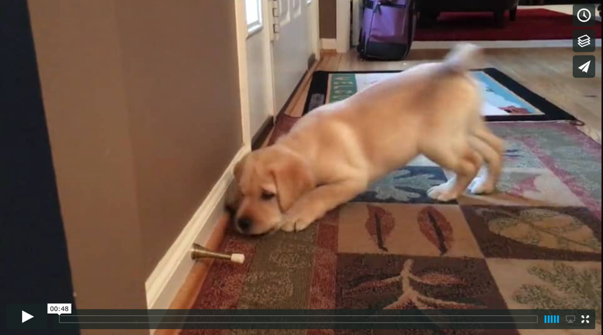

These days, I don’t know who’s more easily entertained: him or me.

It’s moments like this that make forget that we are stuck in the house and can’t really go anywhere. Let’s face it our dogs bring so much joy to our lives, but they can also be challenging if they don’t get enough exercise and attention.

That’s why we decided to help you while you and your dog have time on your hands right now! We are offing a special online trick training program that you and your dog can do at home.

Got kids at home? Even better…get the kids to do the training and everyone wins!

For only $99, you get a full year of access access to this self-guided, online course, which includes Over 35 videos teaching 15 different tricks including:

- The basics (sit, down, name game, stay)
- Kennel up
- Shake
- Spin
- Roll over/play dead
- Go to mat
- Platform training
- Leave it
- Drop it
- Peekaboo
- Muffin tin game
- Ring the bell
- Back up
- Weave between legs
- Say your prayers
- Jump through arms

{Button} Join Today

It’s like having your own personal certified trainer by your side every step of the way! As a matter of fact, that’s exactly what you have because the course is taught by Certified Professional Dog Trainer, Robin Bennett, CPDT-KA. She is a professional dog trainer and a leader in positive training. Robin was the past chair of the Association of Professional Dog Trainers and is co-founder of The Dog Gurus. She knows her stuff!

I just like the way that Robin simplifies things so that ANYONE can learn to do it the right way. -Donna Pearman

This is a great opportunity to build a relationship with your dog AND it’s a great opportunity to help our facility continue to work with our pet parents during the time when we have so few dogs onsite with us.

[ADD ANY OTHER BONUSES THEY MIGHT GET SUCH AS ACCESS TO A PRIVATE FACEBOOK GROUP WITH YOUR TEAM

So don’t delay! Sign up today!

{Button} Join Today

Signature

P.S. This course makes a great gift, too! If you know someone else who is home with their dog right now consider giving them the gift of a tricks class!

